%% Linear Algebra: G.Strang, ” Differential Equations and Linear Algebra”, Wellesley- Cambridge Press,2014.

Chapter 4 to Chapter 8

1. Linear Equations and Inverse matrices
2. Vector Spaces and Sub Spaces
3. Eigenvalues and Eigenvectors
   1. Introduction to e-values
   2. Diagonalizing a matrix
   3. Linear systems $y^{'}=Ay$
   4. The Exponential of a matrix
   5. Second Order systems and symmetric matrices
4. Applied mathematics and ATA
5. Fourier and Laplace Transforms

%%

* 1. Introduction to Eigenvalues

Def(Kim):

Given a square matrix $A_{n×n }, λ$ and corresponding $x , x≠0$, satisfy the following eq. as

$$Ax=λx,$$

We call $λ:$ eigenvalue, $x:$ eigenvector

Fact(Kim)

1. eigenvalue

$\left|A-λI\right|=0, \left|M\right|:$ the determinant of the matrix M

1. eigenvector $x$

The solution to the homogeneous solution which is non-zero vector

$$\left(A-λI\right)x=0 , -→x∈ Ν(A-λI)$$

Ex: $A=\left[\begin{matrix}1 & 2 \\ 0 & 3\end{matrix}\right]$,

${ λ}_{1}=1, x_{1}={\left(1,0\right)}^{T}$

$${ λ}_{2}=3, x_{1}={\left(1,1\right)}^{T}$$

* Eigenvalues are the key to a system of $n$ differential equations



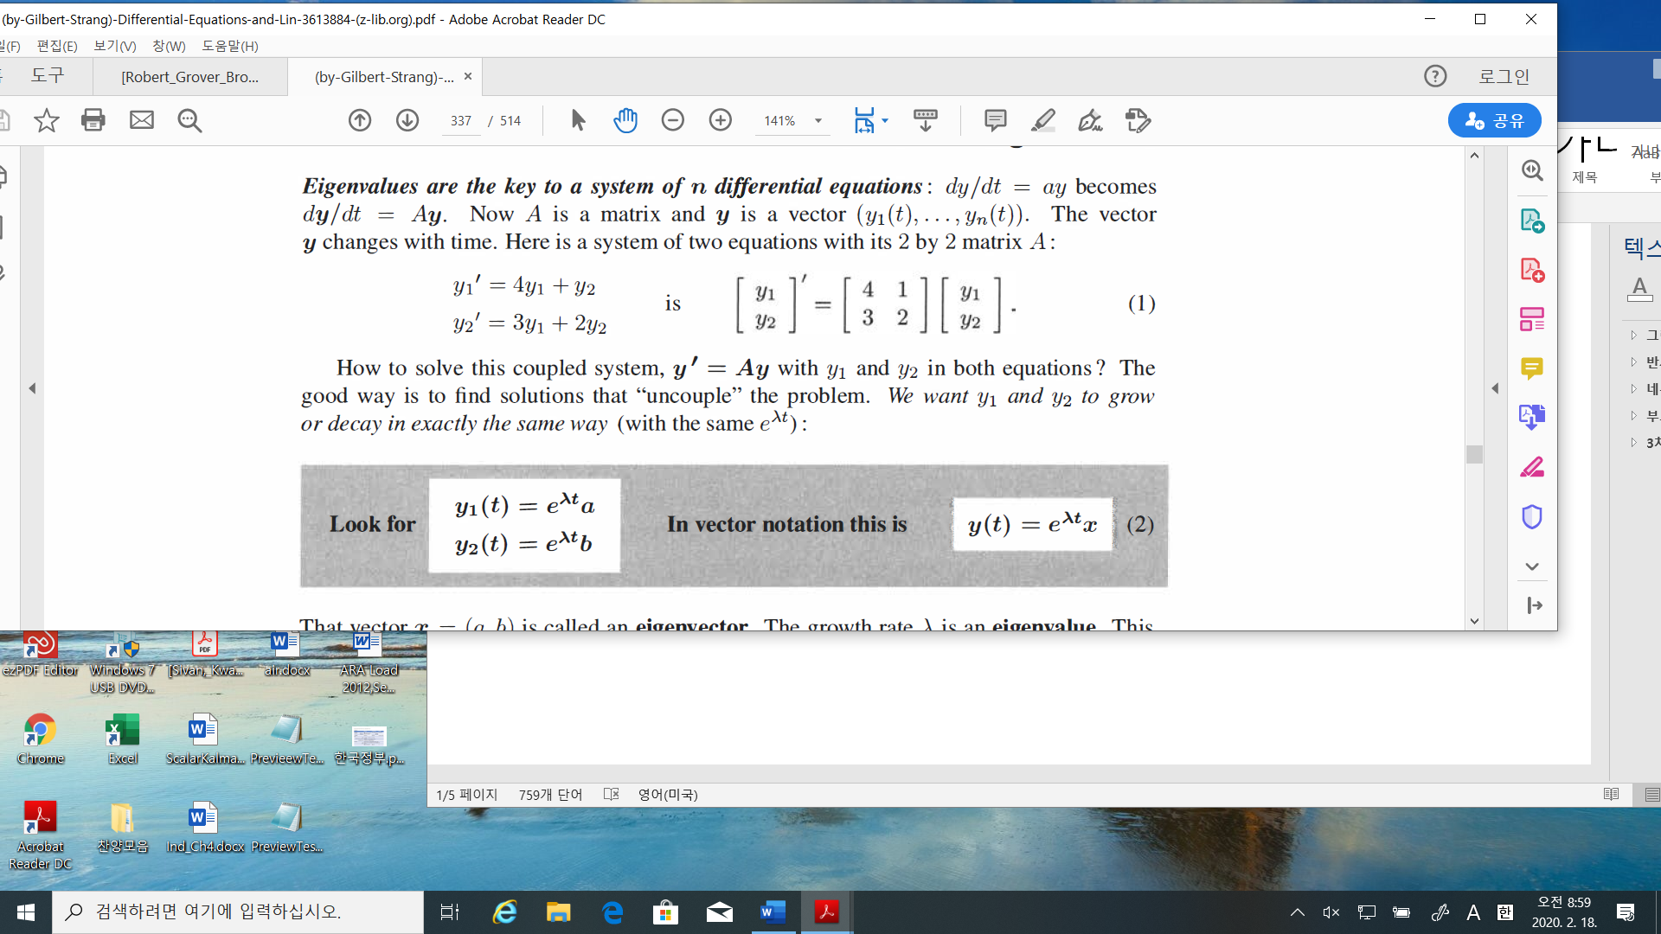

Looking for the solution as

$$y\left(t\right)=e^{λt}x,λ:eigenvalue, x:eigenvector$$

1. Find the e-values and e-vectors

$$λ_{1}=5, x_{1}= \left[\begin{matrix}a \\ b\end{matrix}\right]=\left[\begin{matrix}1 \\ 1\end{matrix}\right]$$

Then

$$y\left(t\right)=e^{5t}\left[\begin{matrix}1 \\ 1\end{matrix}\right]-→ {\left[\begin{matrix}y_{1} \\ y_{2}\end{matrix}\right]}^{'}=\left[\begin{matrix}5e^{5t} \\ 5e^{5t}\end{matrix}\right]=\left[\begin{matrix}4 & 1 \\ 3 & 2\end{matrix}\right]\left[\begin{matrix}y_{1} \\ y_{2}\end{matrix}\right]-→OK.$$

$$λ_{2}=1, x_{2}= \left[\begin{matrix}1 \\ -3\end{matrix}\right]$$

$$y\left(t\right)=e^{t}\left[\begin{matrix}1 \\ -3\end{matrix}\right]-→ {\left[\begin{matrix}y_{1} \\ y_{2}\end{matrix}\right]}^{'}=\left[\begin{matrix}e^{t} \\ -3e^{t}\end{matrix}\right]=\left[\begin{matrix}4 & 1 \\ 3 & 2\end{matrix}\right]\left[\begin{matrix}y_{1} \\ y_{2}\end{matrix}\right]-→OK.$$

1. 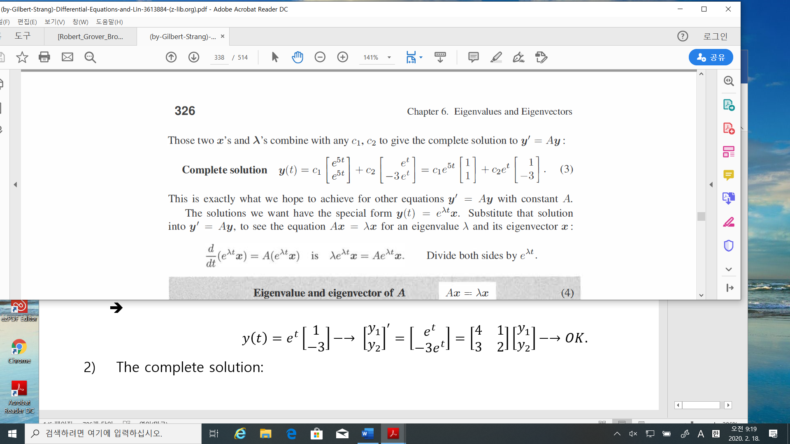 The complete solution: 🡪 homogeneous solution 🡪 null solution
2. 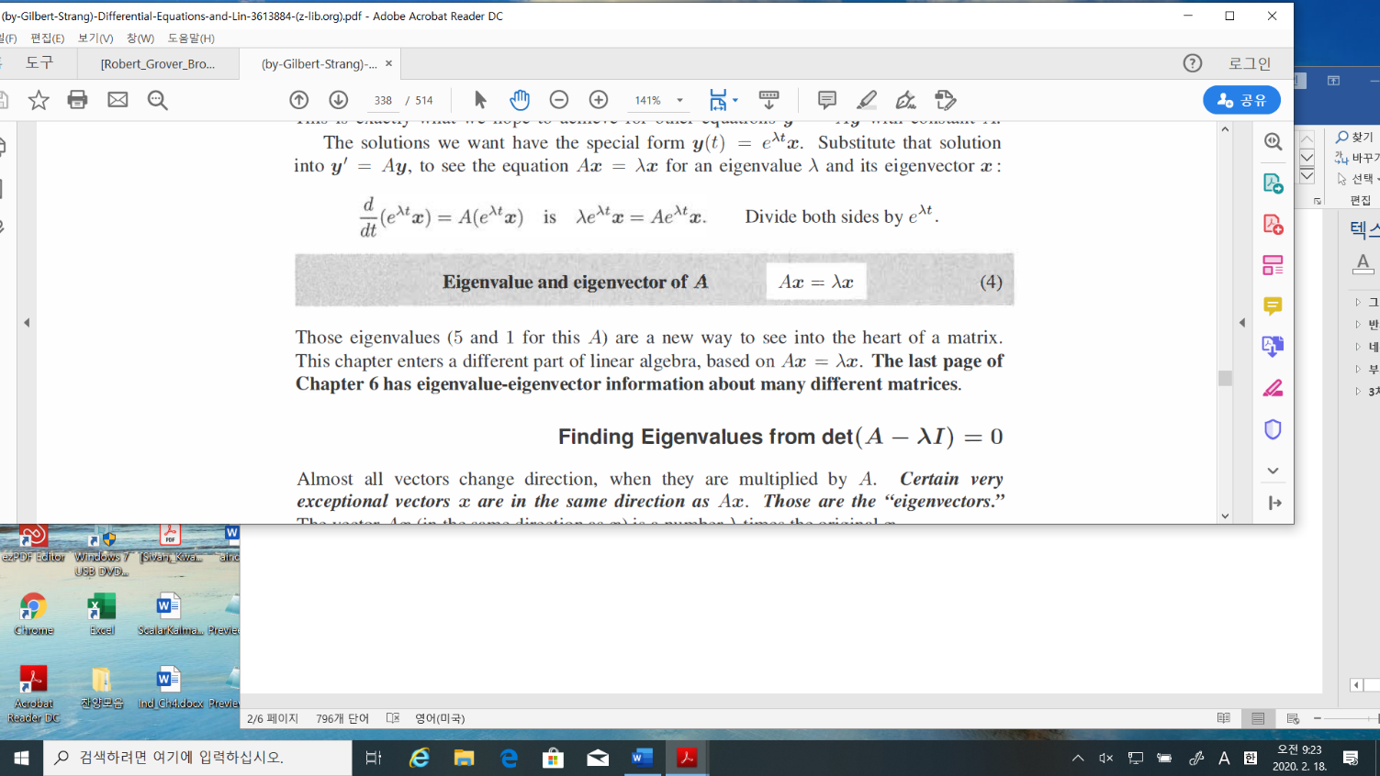Why does this happen?



* Finding the e-values and e-vectors. Let $A= \left[\begin{matrix}a & b \\ c & d\end{matrix}\right]$
$$Ax =λx-→\left(A-λI\right)x=0$$

* For $x≠0, A-λI$ is a singular matrix, i.e., the determinant must be zero.
* The determinant of $A-λI=det\left[\begin{matrix}a-λ & b \\ c & d-λ\end{matrix}\right]=\left(a-λ\right)\left(d-λ\right)-bc=0$
* Exam. 1 Let $A= \left[\begin{matrix}4 & 1 \\ 3 & 2\end{matrix}\right]$

1. E-values:

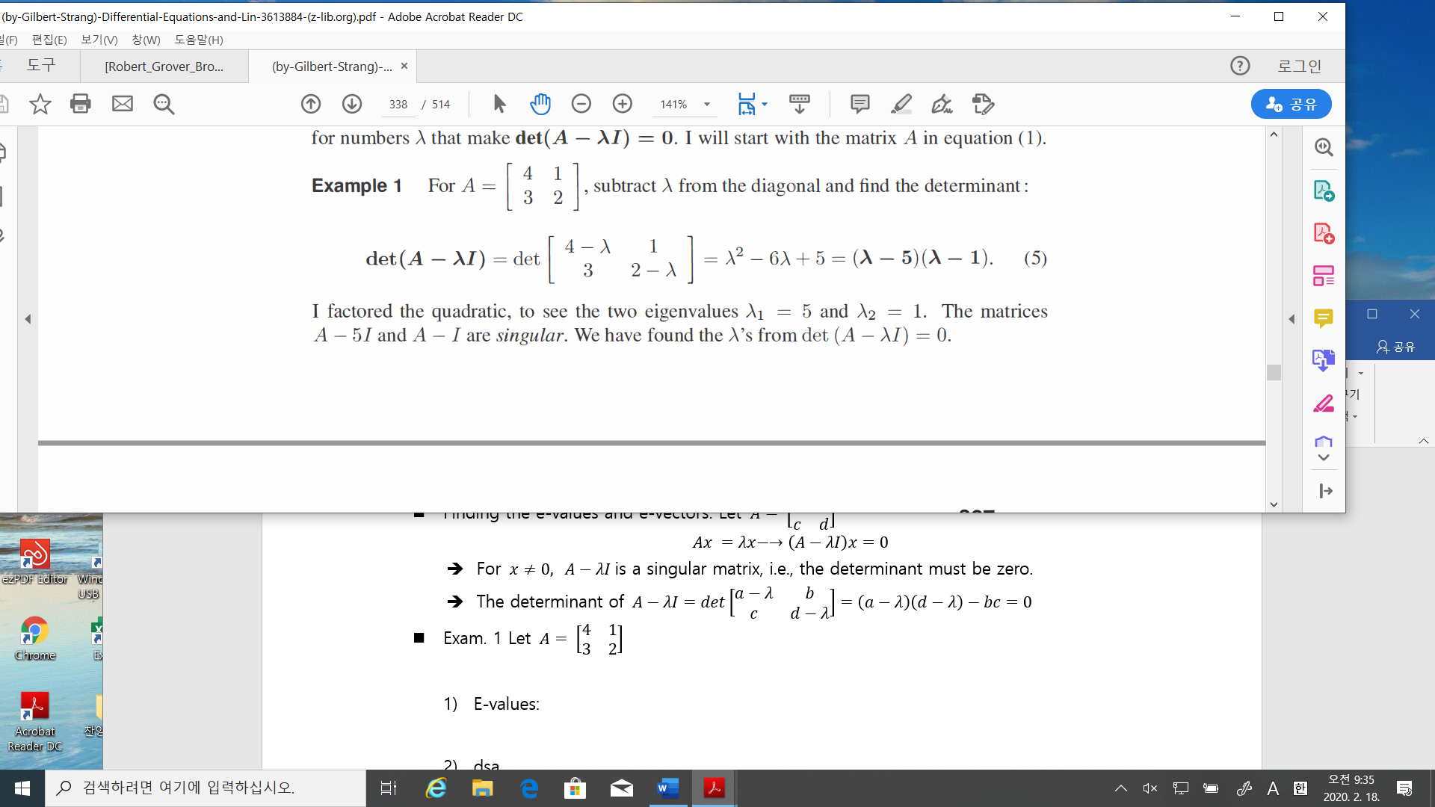

1. E-vectors:

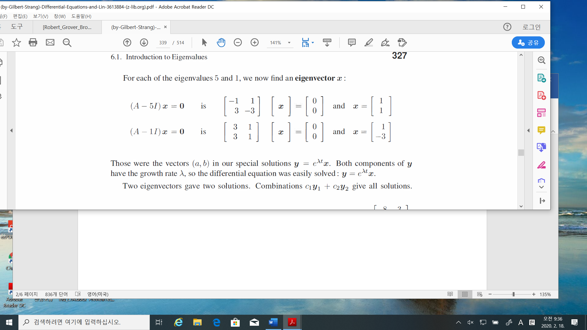

* Powers of matrix: if $Ax=λx,$ then

$$A^{k}x=λ^{k}x$$

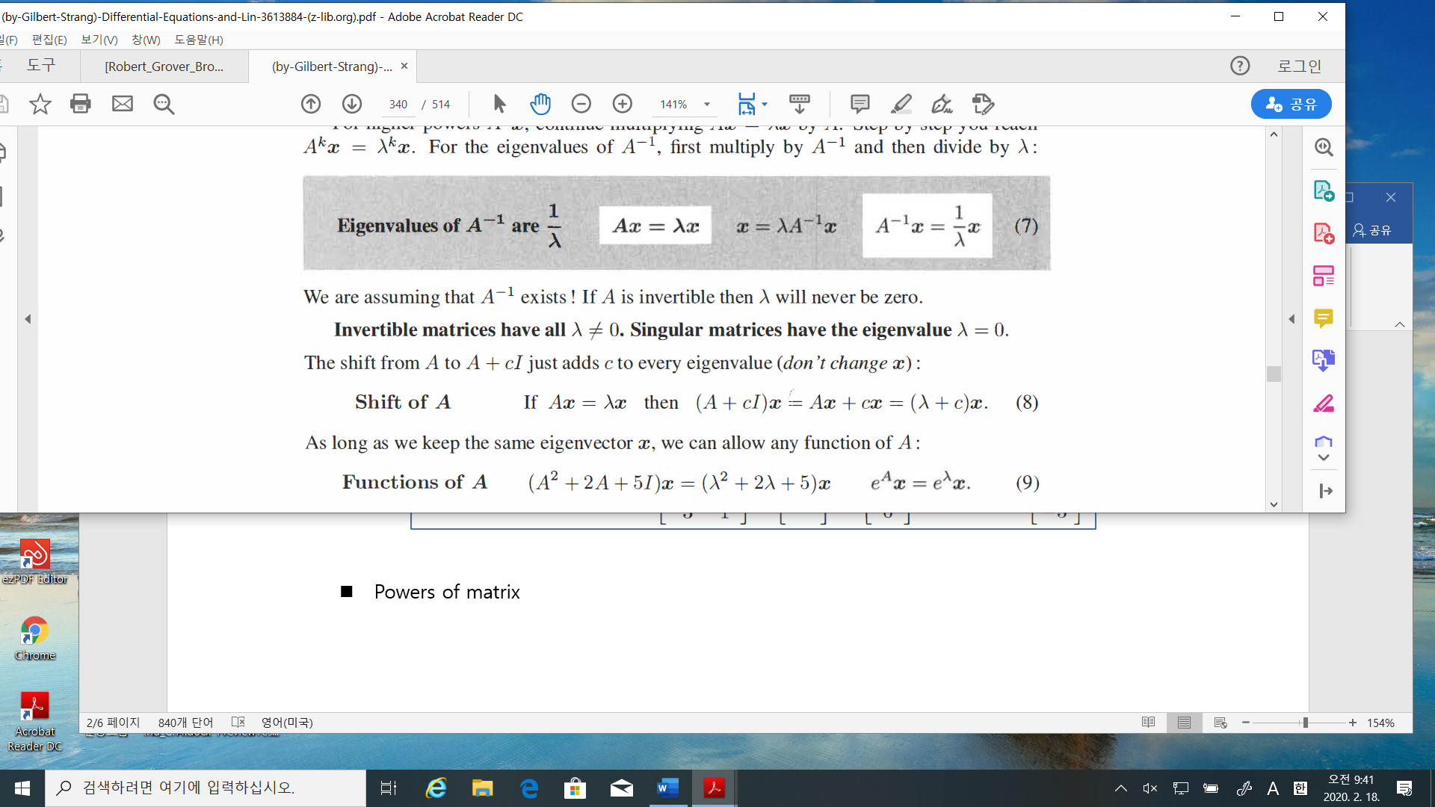



* Facts:



1. Invertible matrices have all $λ≠0.$



Not invertible matrix 🡪 singular matrix

1. Shift of $A$: if $Ax=λx$, then
$$\left(A+cI\right)x =\left(λ+c\right)x$$

2. Functions of $A$: if $Ax=λx$, then

$$\left(A^{2}+2A+5I\right)x=\left(λ^{2}+2λ+5\right)x$$

$$A^{k}x=λ^{k}x$$

$$e^{A}x=e^{λ}x$$

%% kim’s comment : exponential

1. definition

$$e= \lim_{n→∞}{{\left(1+\frac{1}{n}\right)}^{n}}=2.7….$$

test: for n =1 to 10

2.0000 2.2500 2.3704 2.4414 2.4883 2.5216 2.5465 2.5658 2.5812 2.5937

-> converge to the some number to 2.71….

-> it is an irrational number

$e^{x} = \lim_{n→∞}{{\left(1+\frac{x}{n}\right)}^{n}}$

1. Derivative
$$\frac{{de}^{x}}{dx}=\frac{d}{dx}\left(\lim_{n→∞}{{\left(1+\frac{x}{n}\right)}^{n}}\right)= \lim_{n→∞}{\frac{d}{dx}{\left(1+\frac{x}{n}\right)}^{n}= \lim_{n→∞}{n \left(\frac{1}{n}\right){\left(1+\frac{x}{n}\right)}^{n-1}}}$$

$$=\lim_{n→∞}{\left(1+\frac{x}{n}\right)}^{n}{\left(1+\frac{x}{n}\right)}^{-1}=\lim_{n→∞}{\left(1+\frac{x}{n}\right)}^{n}\lim_{n→∞}{\left(1+\frac{x}{n}\right)}^{-1} \\ =e^{x}\lim_{n→∞}{\left(1+\frac{x}{n}\right)}^{-1}=e^{x}\lim_{n→∞}\left(\frac{n}{n+x}\right)=e^{x}\lim_{n→∞}\left(\frac{1}{1+\frac{x}{n}}\right) \\ =e^{x}(1/(1+ \lim_{n→∞}{\frac{x}{n}))=e^{x} }$$

2. Taylor series of $e^{x}$
$$e^{x}=1+x+\frac{x^{2}}{2}+,…$$

3. Complex exponential

$$e^{ix}=1+ix+\frac{{\left(ix\right)}^{2}}{2}+,… \\ =\cos{x}+i\sin{x}$$

where . 🡪 Euler’s law

1. Matrix exponential

$$e^{A}=1+A+\frac{A^{2}}{2}+,…$$

If $Ax =λx, then$

$$e^{A}x=\left(1+A+\frac{A^{2}}{2}+,…\right)x=\left(1+λ+\frac{λ^{2}}{2}+…\right)x=e^{λ}x$$

%%% %%%

1. E-values of $\left(A+B\right) ≠$ E-values of $A$ + E-values of $B$
2. E-values of $AB$ = E-values of (BA) but not equal to (E-values of (A)) x ((E-values of (A))



* Determinants

1. If $A= \left[\begin{matrix}a & b \\ c & d\end{matrix}\right]$, determinant of $A$ = det($A)$ = $\left(ad-bc\right)$
2. If $A$ is a triangular matrix, then det($A)=product of diagonal entries$

$\det\left(AB\right)=\det\left(A\right)\det\left(B\right)$

$\det{(A)}=det⁡(A^{T})$

* Example 3: $S= \left[\begin{matrix}2 & 1 \\ 1 & 2\end{matrix}\right]$, then E-values of $A=3, 1$ and each e-values has an e-vector as

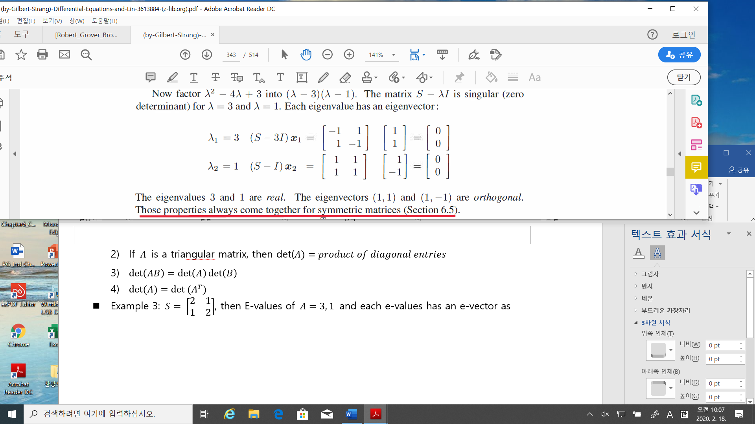

* Example 4: Complex e-values/e-vectors $A= \left[\begin{matrix}0 & -1 \\ 1 & 0\end{matrix}\right]$

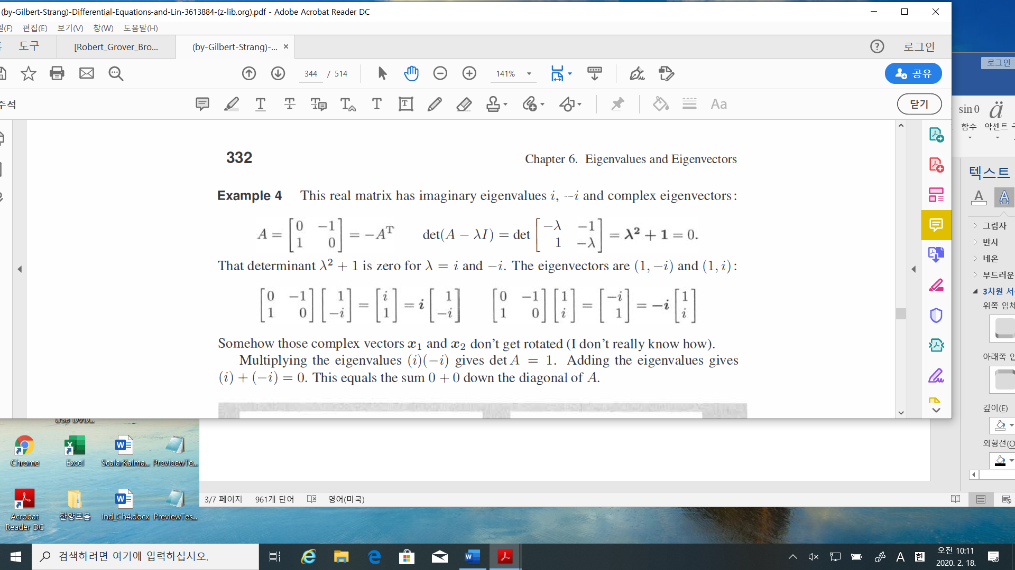

* Problem: find e-values/vectors of $A= \left[\begin{matrix}\cos{θ} & -\sin{θ} \\ \sin{θ} & \cos{θ}\end{matrix}\right]$
  1. Diagonalizing a matrix

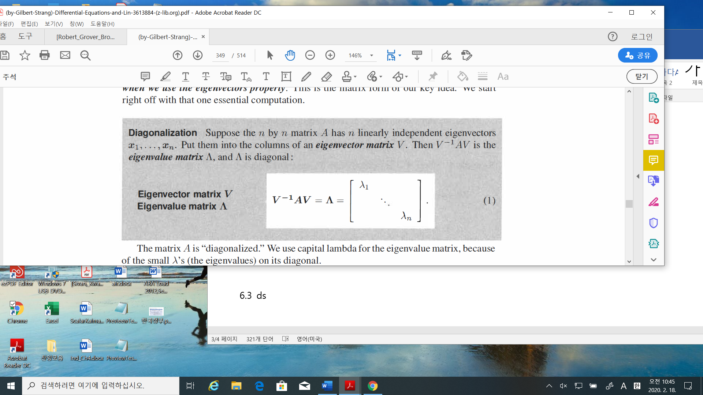

* **The condition of linearly dependent e-vectors are important.**
* Example_1

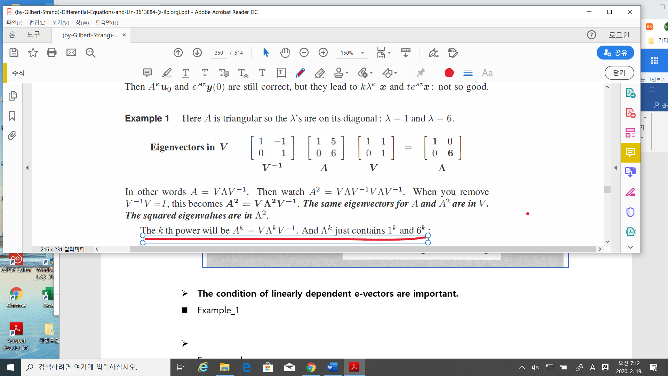

* Facts:

Let $V^{-1}AV =Λ$, then $A=VΛV^{-1}$

$$A^{2}=\left(VΛV^{-1}\right)\left(VΛV^{-1}\right)=VΛ^{2}V^{-1} \\ A^{k}=VΛ^{k}V^{-1} \\ A^{-1}={\left(VΛV^{-1}\right)}^{-1}={\left(V^{-1}\right)}^{-1}Λ^{-1}{\left(V\right)}^{-1}=VΛ^{-1}V^{-1}$$

* Remarks(page 338)

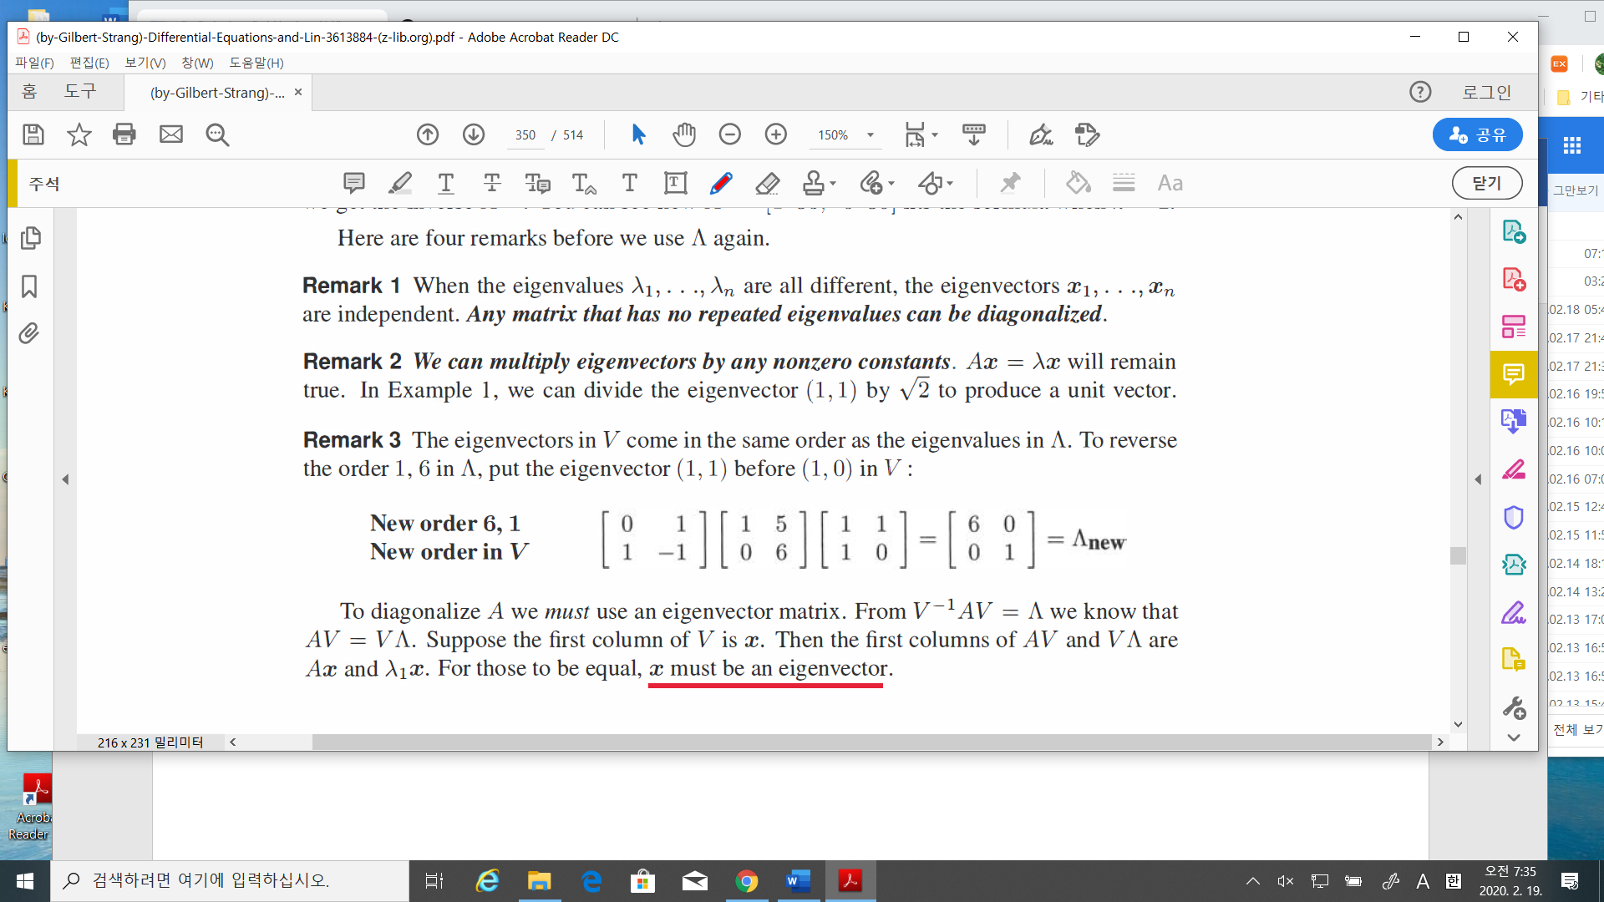

* So if e-values are different, **then e-vectors is a basis**, i.e., for any $x∈R^{n},$

$x=c_{1}x_{1}+c_{2}x_{2}+,…+c_{n}x_{n}$

* 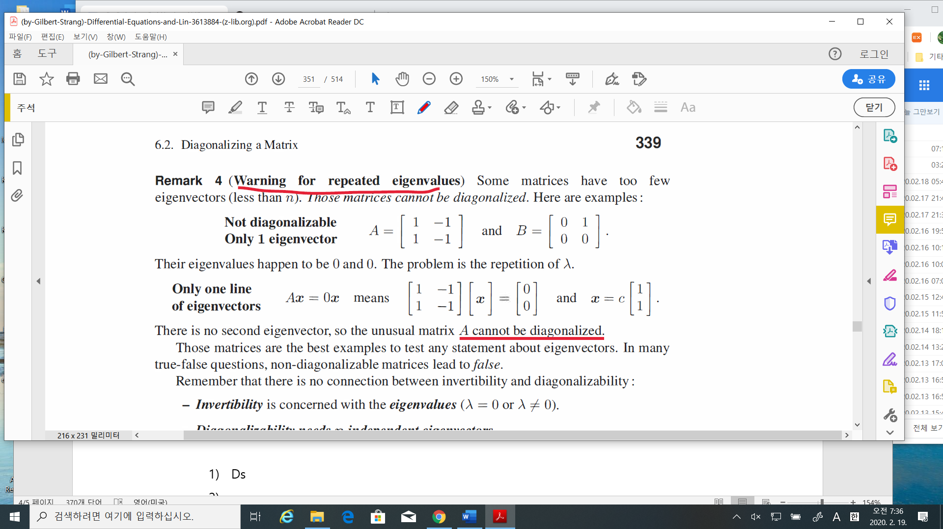Remarks(page 339)
* For example

$$A=\left[\begin{matrix}1 & 1 \\ 0 & 2\end{matrix}\right], B=\left[\begin{matrix}1 & 0 \\ 0 & 1\end{matrix}\right], C=\left[\begin{matrix}1 & 1 \\ 0 & 1\end{matrix}\right]$$

$A$ is diagonalizable, B is already diagonalized(even if the e-values are equivalent)

But $C$ cannot be diagonalizable.

* Remarks.

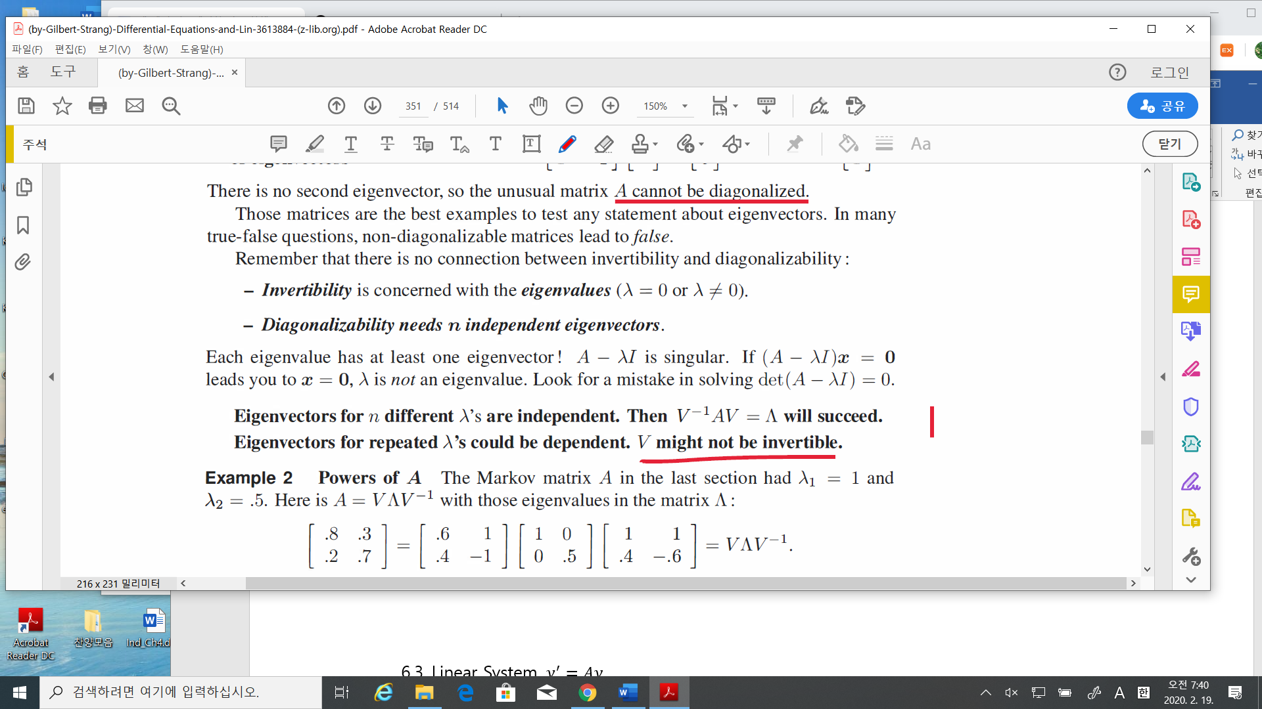

* Let $A_{n×x}$. How many e-values of ? 🡪 if allowed the multiplicity, there are $n$ e-values.

How many e-vectors of 🡪 <= n

* Problem: Find e-values and e-vectors of $B,$ and C
$$B=\left[\begin{matrix}1 & 0 \\ 0 & 1\end{matrix}\right], C=\left[\begin{matrix}1 & 1 \\ 0 & 1\end{matrix}\right]$$

* Matrix Power $A^{k}$

1. Solution to a difference equation



$$u_{k+1}=Au_{k} , u_{0}(initial condition)$$

$u_{k}=Au_{k-1}= A^{2}u_{k-2}===.>A^{k}u_{0}$

* If $A$ is diagonalizable, $A=V^{-1}ΛV$, then

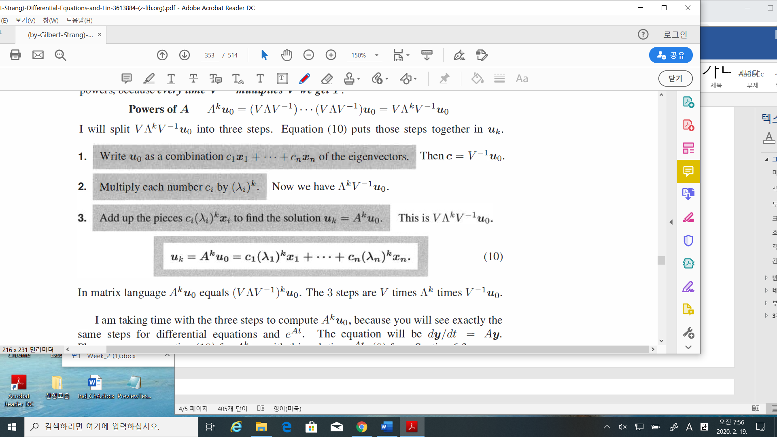

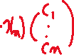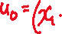

1. The solution to a differential equation

$$\frac{dy}{dt}=Ay$$

$$y\left(t\right)=e^{At}y\left(0\right)=c_{1}e^{λ_{1}t}x_{1}+ c_{2}e^{λ_{2}t}x_{2}+ ,…, + c_{n}e^{λ_{n}t}x_{n}$$

* Keep in mind.

1. $\left(λ_{1}, x_{1}\right), \left(λ_{2}, x_{2}\right),…,$ they are corresponding to each other
2. These solution are correct if $A$ is diagonalizable, i.e., “n” e-vectors are independent



* Example 3(page 342): Solution to a difference equation.

Find

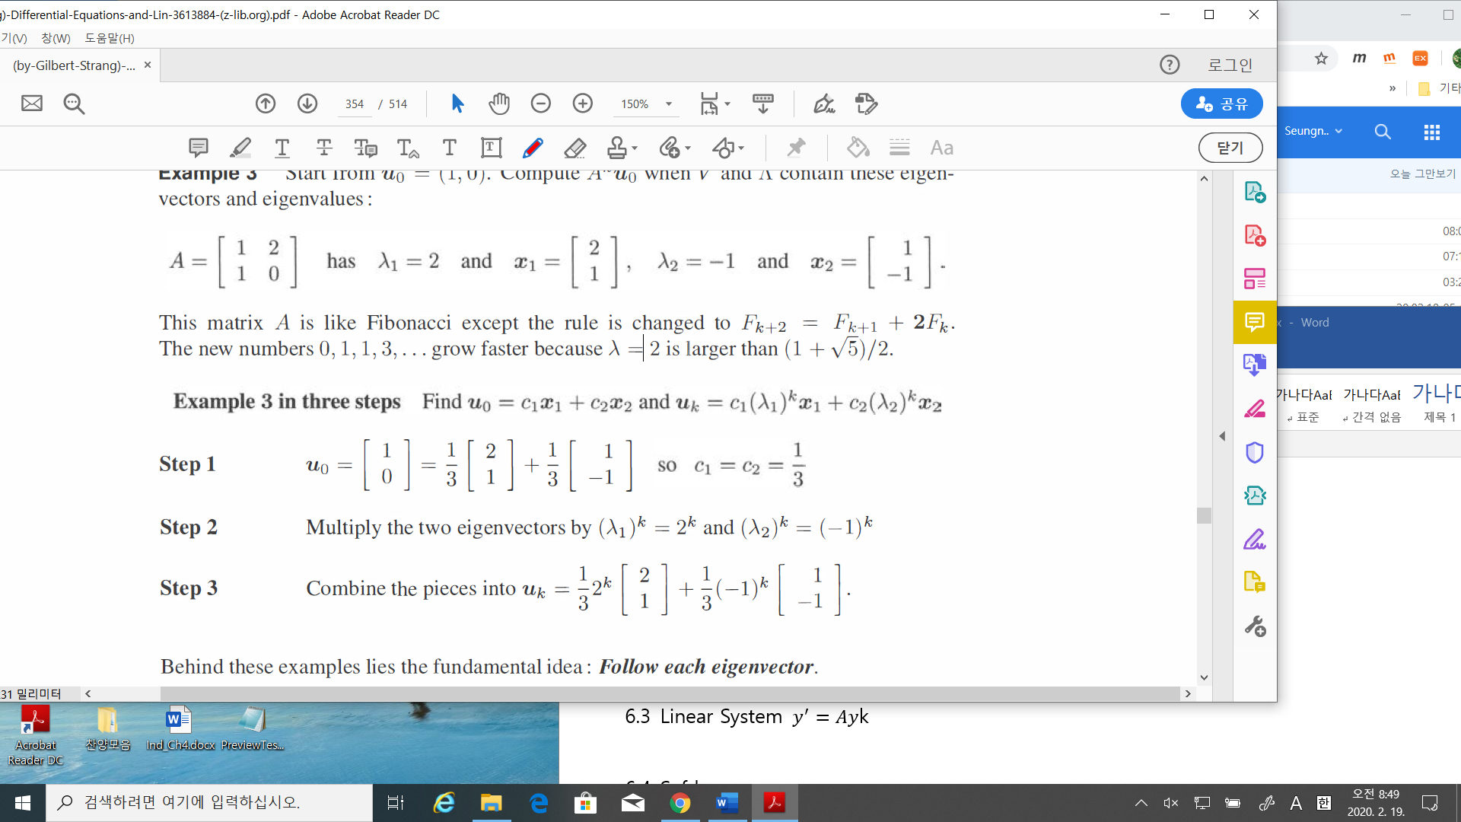



* 1. Linear System

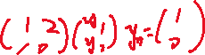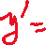

* Introduction:

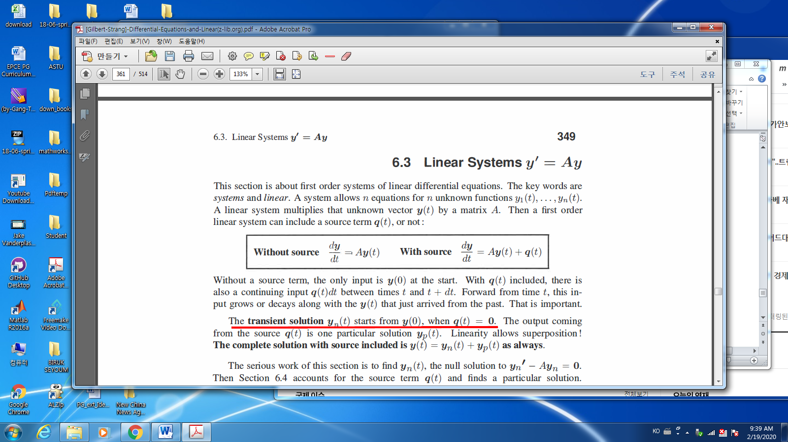

-The solution form:

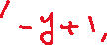

: The complete solution;

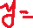

: The particular solution; $y_{p}\left(t\right)$



: The null (transient / homogeneous ) solution;



* Example_1: Real different e-values;

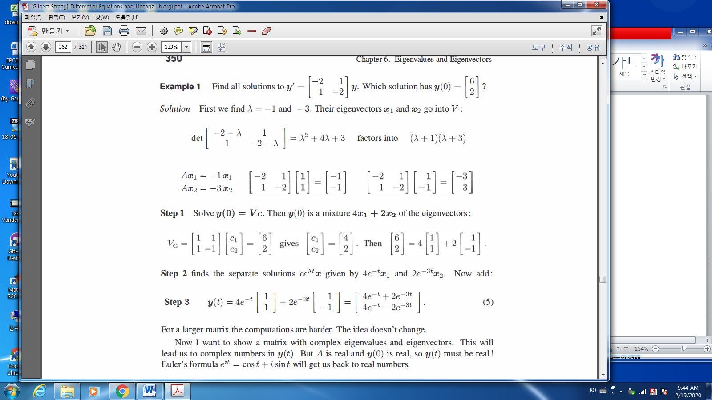



* Do U know the phase plot of the state? 🡪 non-linear system?
* Example_2: Complex e-values

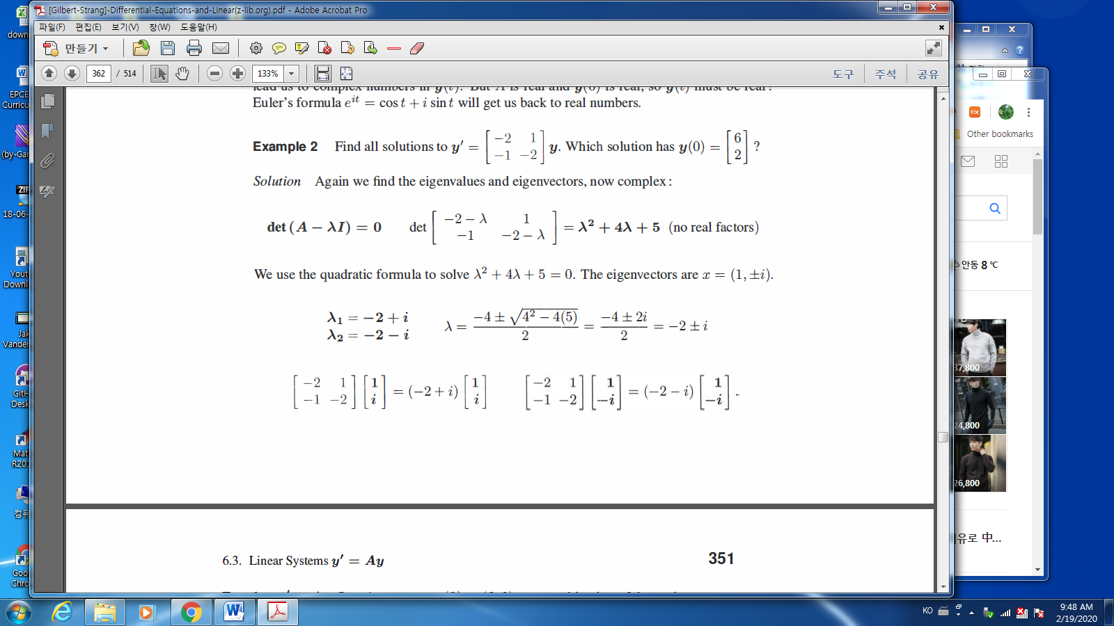

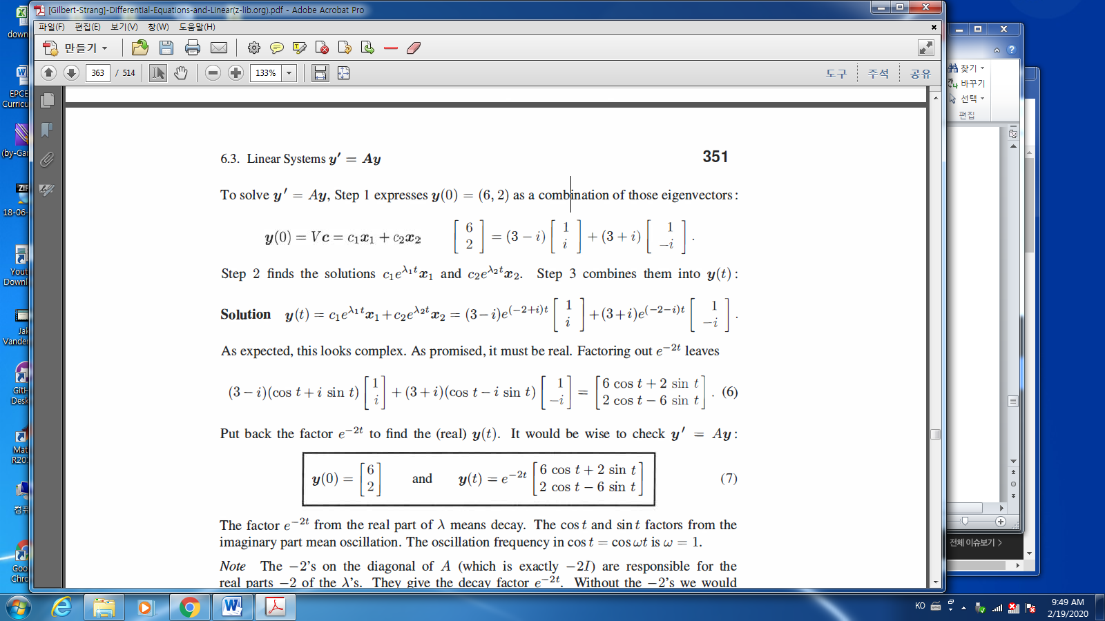



* Companion matrices:

Companion matrices: have 1’s on their super diagonal:

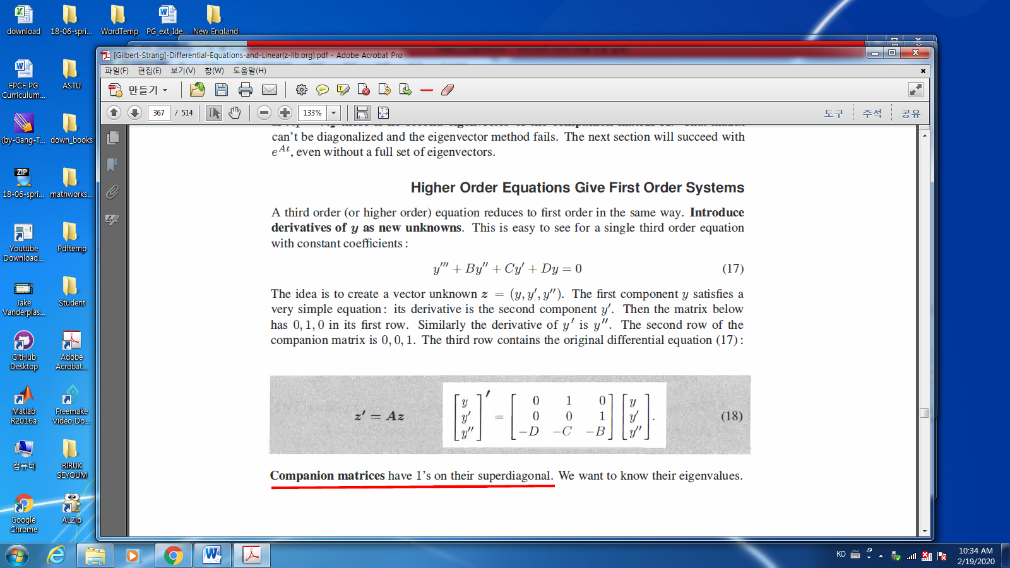

* Find e-values (Determinant of $(A-λI)$)

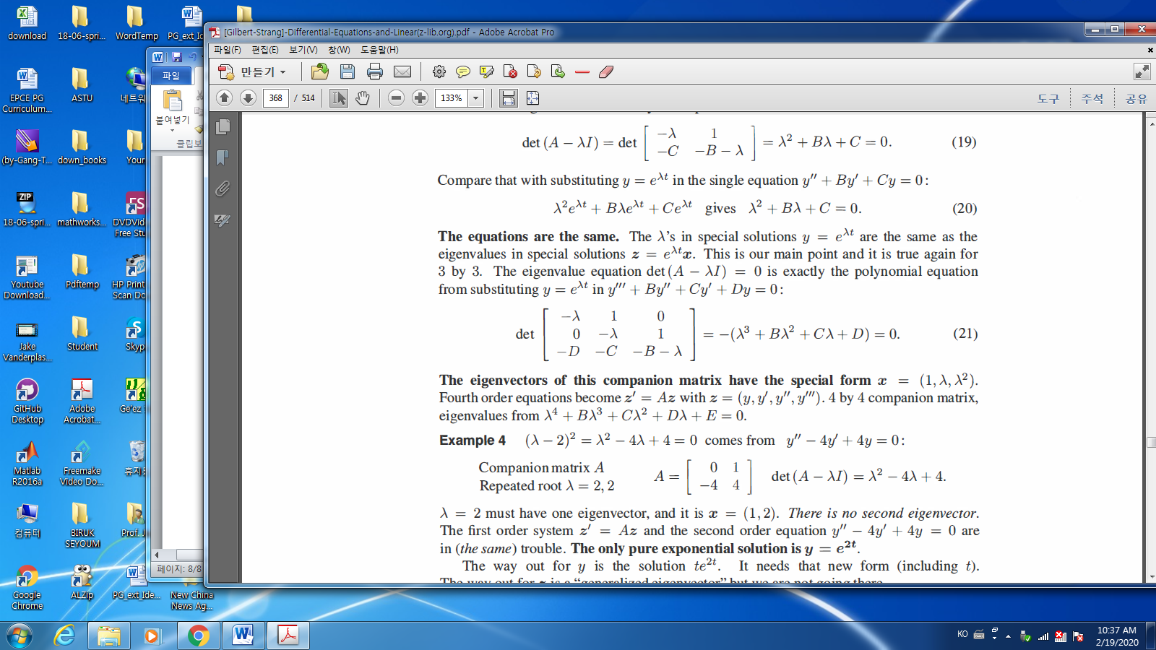

* Look the e-vectors!!

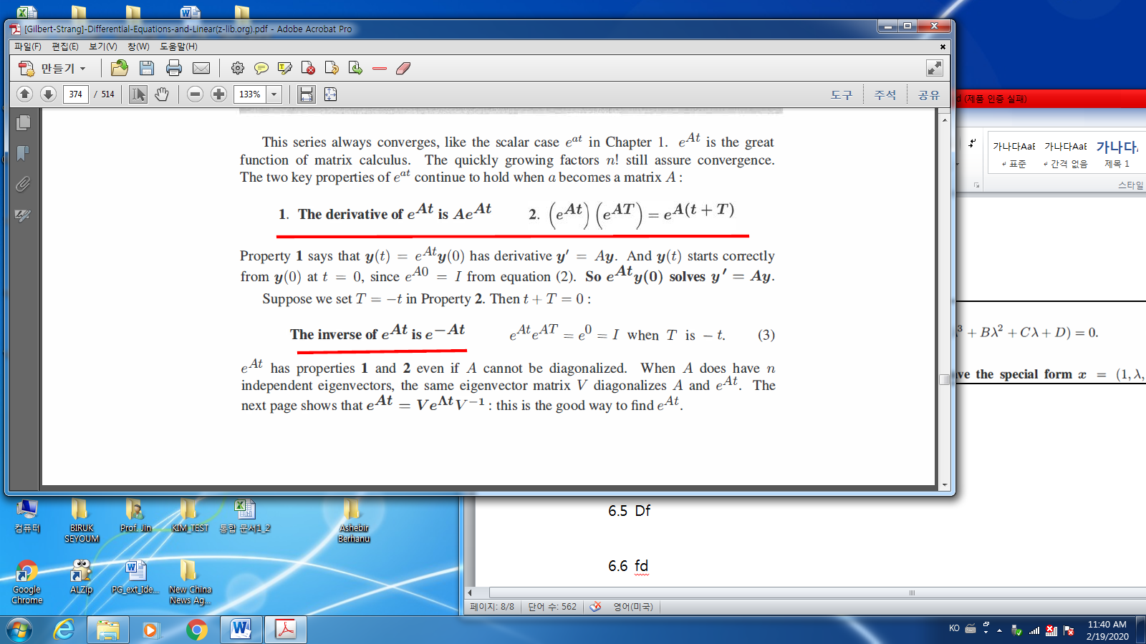

* Source term in $y^{'}=Ay+q$

1. If $q$ is constant, then

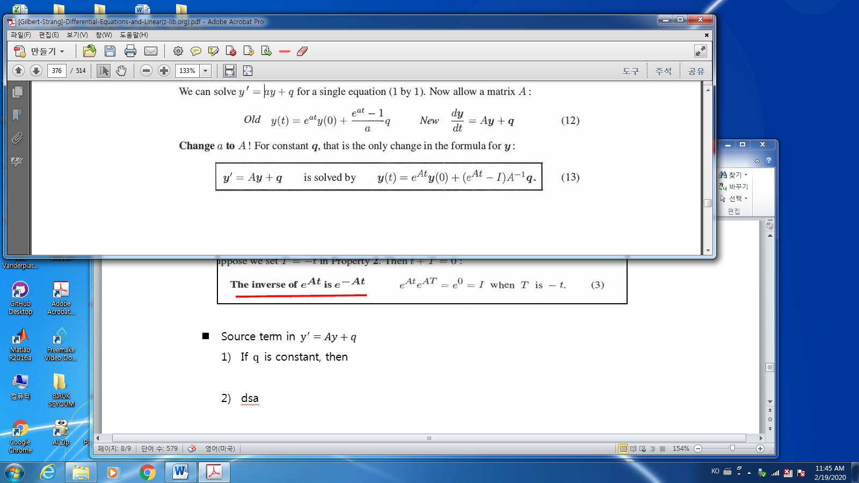

1. In general,

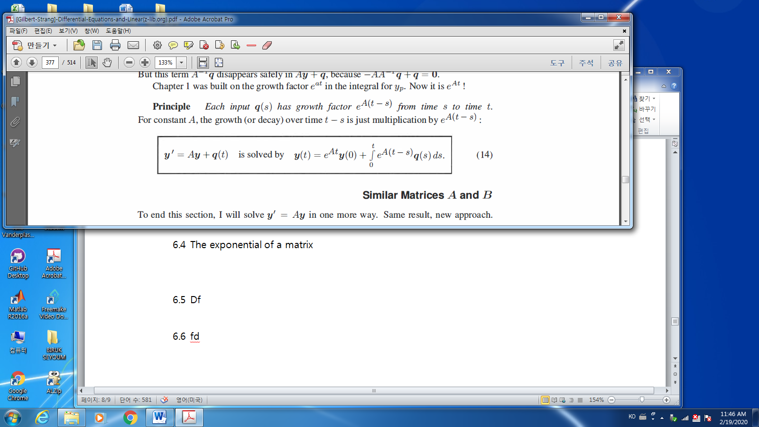

* 1. The exponential of a matrix 🡪 skip
  2. Second order systems and Symmetric matrices 🡪 skip
* Problem: find e-values/vectors of $A= \left[\begin{matrix}\cos{θ} & -\sin{θ} \\ \sin{θ} & \cos{θ}\end{matrix}\right]$
* Problem: Find e-values and e-vectors of $B,$ and C

$$B=\left[\begin{matrix}1 & 0 \\ 0 & 1\end{matrix}\right], C=\left[\begin{matrix}1 & 1 \\ 0 & 1\end{matrix}\right]$$

Problem.

Chapter. 6.1 2 / 3 / 6 / 20

Chapter. 6.3 1/ 7 /10